Beginning Orchestra
Supply List
Daily Supplies: Instrument and Supplies for your instrument
From any music store:
- Instrument
- Rosin
- Cleaning Cloth
- Shoulder Rest- EVEREST (violin/viola)
- Rock Stop (cello/basses)
- Essential Elements for Strings Book 1, Brown (make sure to get the one for YOUR instrument) Formerly Essential Elements 2000
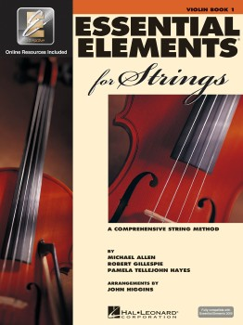
- Tuner: Korg PC-1 (Violin, Viola, Cello)/Korg AW2 Bass
- Folding Wire Music Stand
From any office supply store:
- 1” 3-ring Black Binder to be used for ORCHESTRA ONLY!
- Dividers (8 with labels)
- No. 2 Pencils (NO PENS)
- Highlighter (any color)
Recommended Music Stores:
Williamson Music 1st- (469) 362-7171 6807 Main Street, Frisco TX 75034
Cadenza Violins- (469) 241-1152 6905 Coit Rd, Plano 75024
Dallas Strings- (469) 675 0085 • 20 East McDermott Road Allen, Texas 75002
Luthier Shop- (940) 365-2309 2201 Moseley Rd, Cross Roads, TX 76227

